



Application Architecture Domain Model

Domain Model for: <Domain Name>

Table of Contents

1 Purpose of this Document 3

1.1 Conventions in the Document 3

2 Sub-Domain Summary 3

2.1 Business Capabilities Provided 3

2.2 Core Elements 4

2.3 API Layer 5

2.3.1 API Inventory 5

2.3.2 API Resources Specifications 8

2.4 Core Domain 10

2.4.1 Aggregates. 10

2.4.2 Commands, Queries and Services 15

2.4.3 Domain Events 16

2.4.4 Objects 18

2.5 Integration Layer 20

2.5.1 External Events 20

2.5.2 Events Handlers 20

2.5.3 External Services 21

2.5.4 External API and External Systems 23

2.5.5 Objects 24

3 APPENDIX 1: Architectural Style 26

4 APPENDIX 2: Modelling in Archimate 28

4.1 Business Capabilities Map 28

4.2 API Layer 29

4.2.1 API Inventory 29

4.2.2 API Specification 30

4.2.3 API Resources Specifications 34

4.3 Core Domain 34

4.3.1 Aggregates 35

4.3.2 Aggregate and Entity Lifecycle Diagrams 36

4.3.3 Commands Specification 37

4.3.4 Service Specifications 39

4.3.5 Query Specifications 41

4.3.6 Domain Events 43

4.3.7 Objects 44

4.4 Integration Layer 46

4.4.1 External Events 47

4.4.2 Events Handlers 48

4.4.3 External API and External Domains 49

4.4.4 External Services 50

Document Information

|  |  |  |  |
| --- | --- | --- | --- |
| **Project Name:** |  | | |
| **Prepared By:** | <Alfredo Munoz> change name | **Document Version No:** | 1.0 |
| **Title:** | Component Design: <Domain Name> | **Document Version Date:** |  |
| **Reviewed By:** |  | **Review Date:** |  |

Document Version History

| **Version Number** | **Version Date** | **Revised By** | **Description** | **Filename** |
| --- | --- | --- | --- | --- |
| 1.0 |  |  |  |  |
|  |  |  |  |  |

# Purpose of this Document

This document provides a High-Level Design Specifications for the captioned Domain. This document may be accompanied with an ArchiMate file with the diagrams and elements included in the document. For better understanding of the ArchiMate template, the architecture style applied, and explanations of the different elements of the design, APPENDIXES 1 and 2 are provided.

## Conventions in the Document

Normal text in the template is part of the template and should remain as part of the deliverable

*Red Italic are used to provide examples and should be removed in the deliverable*

<Green Text into max/min symbols is used to provide guidance an should be removed in the deliverable>

# Sub-Domain Summary

<Provide a general description of the domain objectives. >

*Example:*

*The purpose of the Entitlement domain is to provide administration and decisioning capabilities in the evaluation of Entitlement policies. Entitlement policies govern the access of the users and customers to the data and services provided*

## Business Capabilities Provided

<Describe the target capabilities provided in the Domain>

| **Name** | **Target Capability** |
| --- | --- |
| *Policy Authoring* | *Capability to create and administer entitlement policies without changes in the software* |
| *Entitlement Policies Evaluation* | *Evaluate entitlement policies for access to data and banking product and services, based on information about the customer, channels and products* |
| *Policy Impact Analysis* | *Evaluate the impact in the changes in policies by reevaluating a historic of polices evaluations* |
| *Policy Administration* | *Manage who can create or administer the policies* |
| *Entitlement Sourcing* | *Capability to link the entitlement granted to users and customer, to the source of the entitlement, such as contracts or consents* |

## Core Elements

<Provide a diagram with the key aggregates, APIs and Dependencies>.

*Example:*

**

<Provide a brief description of each of those elements, with focus on the most important aspects>

* *…*
* *..*
* ***Entitlement Policies Aggregates*** *contains the configuration of the policies to be enforces*
* *…*
* ***/entitlement-policies*** *group of API is used to create and administer the Entitlement Policies*
* *…*
* *The domain depends on* ***Eligibility*** *and* ***Underwriting*** *to evaluate additional policies that can constrain the Entitlements*
* *The domain gets information from* ***Customer*** *and* ***Account*** *Domain to evaluate the policies*
* *The domain gets information from* ***Account*** *Domain as a source of entitlements*
* *…*

## API Layer

This section contains the description of the APIs, which is, one of the two mechanism used by the domain to expose the services and the data,

This layer isolates the service exposing mechanism for the core domain, so that future changes in the API style (from REST to any new trendy style that may come later) do have minimum impact in the business logic of the domain.

### API Inventory

| **Operation** | **Path** | **API Description** |
| --- | --- | --- |
| *POST* | *eligibility-assessment* | *Execute a new eligibility assessment* |
| *GET* | *eligibility-policies/{policy-id}* | *Retrieve an eligibility policy* |
|  |  |  |

<Create a Section of the following for each API>

#### API Specification: <API name> (i.e. GET eligibility-policy/{policy-id})

| **API Description** | *Retrieve a list of policies in the repository* |
| --- | --- |
| **API Purpose** | *Retrieve a list of policies in the repository* |
|  |  |

##### Input

|  |  |
| --- | --- |
| **Operation** | *Get Eligibility Policy by ID* |
| **Param** | *{policy-id}: ID of the policy* |
| **Input Object** | *None* |

#### Output

| **Code** | **Description** | **Output Object** |
| --- | --- | --- |
| <Retrieved_OK  Created_OK  Updated_OK  Deleted_OK  Not_Found  Uncontrolled_Error  Business_Error> |  |  |
| *Retrieved_OK* | *Policy retrieved correctly* | *Eligibility Policy* |
| *Not_Found* | *Policy not found by the ID* | *Generic Error* |

#### API realization

<Provide an API realization diagram>

*Example:*

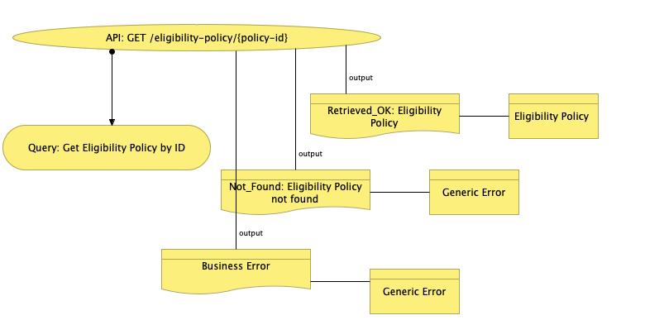

| **Consumed Services** | **Description** |
| --- | --- |
| *Query: Get Eligibility Policy by ID* | *Retrieve an Eligibility Policy* |
|  |  |

### API Resources Specifications

API resources are modeled as Business Objects

<Provide a definition for each the objects used as API resources. If an object contains an attributed that is another object you´ll defined both objects)

#### <Object Name>

| **Attribute Label** | **Name** | **Description** | **Type** | **Constrains** |
| --- | --- | --- | --- | --- |
|  |  |  |  |  |
|  |  |  | * String * Multi-language string * CurrencyAmount * Enumeration * Integer * Date * Timestamp * ObjectName * ObjectReference | Mandatory:  Array:  Enumeration:  Others: |
|  |  |  |  |  |
|  |  |  |  |  |
|  |  |  |  |  |

Example:

| **Attribute Label** | **Name** | **Description** | **Type** | **Constrains** |
| --- | --- | --- | --- | --- |
| *eligibilityCriteria* | *Criteria* | *Criteria elements of the Policy* | *CriteriaObjectSummary* | *Array: Yes* |
| *EligibilityResult* | *Results* | *Result elements of the Policy* | *ResultObjectSummary* | *Array: Yes* |
|  |  |  |  |  |
|  |  |  |  |  |
|  |  |  |  |  |

## Core Domain

### Aggregates.

<Include a diagram with the general view of the aggregates in the entity>

*Example:*

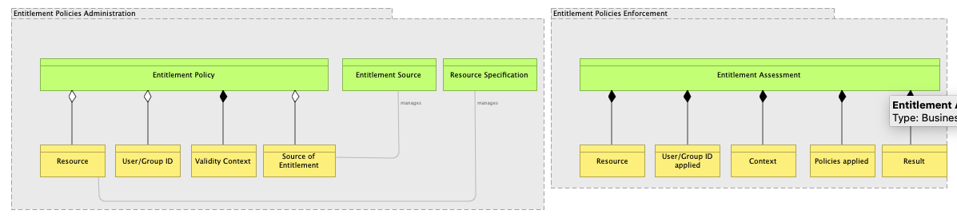

| **Aggregate Name** | **Description** |
| --- | --- |
| *Entitlement Assessment* | *Actual Entitlement Policies Evaluation executed and recorded in the domain. For example, a customer tries to request and it´s found that he´s not entitled to do that. The system evaluates the case and persist all the relevant information about the decision for later use if required* |
| *Entitlement Policies* |  |

#### Aggregate Specification: <Aggregate Name> *(example: Eligibility Policies)*

<Input here the detailed description of the aggregate>

*Example: The Eligibility Policies Aggregates defines the business rules that determent whether a customer can buy a product under specific conditions of price, interest rate, etc. The policies are composed of criteria, results and applicability context)*

<Input here a picture of the structure of the Aggregate>

Example:

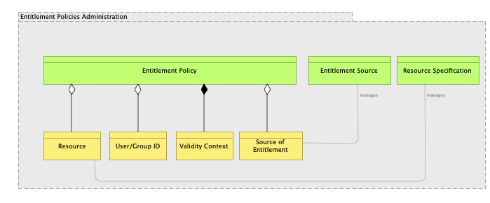

#### Aggregates and Entity Lifecycles

<Include a business object lifecycle diagram for the aggregates and entities>

*Example:*



#### Objects Specification

<Input a section for each object use in the objects>

##### <Object Name> (example: Eligibility Criteria)

<Input here the detailed description of the entity>

*Example: The Eligibility Criteria Aggregates defines the business rules that determent whether a customer can buy a product under specific conditions of price, interest rate, etc. The policies are composed of criteria, results and applicability context)*

| **Attribute Label** | **Name** | **Description** | **Type** | **Constrains** |
| --- | --- | --- | --- | --- |
|  |  |  |  |  |
|  |  |  | * String * Multi-language string * CurrencyAmount * Enumeration * Integer * Date * Timestamp * ObjectName * ObjectReference | Mandatory:  Array:  Enumeration:  Others: |
|  |  |  |  |  |
|  |  |  |  |  |
|  |  |  |  |  |

<Optionally, add an Archimate diagram with the structure of the Entity>

*Example:*

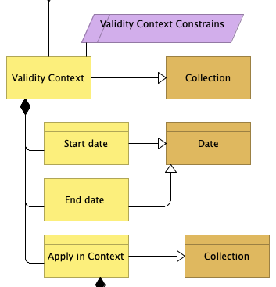

#### Object Instances

<when object instances have to be defined to realize business requirements, for example, for most of types of business policies include a list with the policies>

| **Instance Name** | **Instance Object Type** | **Specific Values of Atributes and Related Instances** |
| --- | --- | --- |
| <name of the object instance> | <object instantiated> | <for example, for a policy, enter the related criteria, result and context object instances> |
|  |  |  |

### Commands, Queries and Services

#### <Type>:<Name>

<type (command, query or service) and name of the command, query or service>

| **Description** | <A description of the purpose of the service, command or query> |
| --- | --- |
| **Input Objects** | <Name of Input Objects. Objects are specified later, in object specifications> |
| **Output Object** | <Name of Output Objects. Objects are specified later, in object specifications  COMMANDS DO NOT HAVE OUTPUTS. ONLY UPDATE THE AGGREGATES.> |

##### Realization Diagram

<provide a Command, Query or Service realization diagram>

##### Main logic flow description

<describe the main logic flow, if needed, to complement the diagram>

###### <Task Name>

<describe the task business logic. Include in tasks the necessary mapping instructions with the called service or object>

###### <Task Name>

<describe the task business logic. Include in tasks the necessary mapping instructions with the called service or object>

###### <…>

<NOTE: When the services call other services or read from an aggregate a mapping to the service interface or aggregate data may be needed, when the mapping won´t be evident for the technical designer. The mapping will be described as part of the logic description of the services or in the tasks

We´ll use simple text to describe how mapping is to be done. The analyst is welcome to use tables such as the one below. This cannot be achieved in Archimate and should be a necessary manual step when creating the deliverable in MS Word.

| **Target Field** | **Source Field** | **Comments** |
| --- | --- | --- |
|  |  |  |
|  |  |  |

>

##### Business Errors

List of possible business errors that the service can produce.

| **Error Code** | **Error Description** | **Error Object Name** |
| --- | --- | --- |
| <Use any error code type 999999999. Do not repeat codes per service. The final code will be <domain>.<service name>.99999999 and will be unique in the system> |  | <The Error Object Name specifies an object with information relevant to report an error or warning. For example,” The Account 1256565 has a not valid status ´on hold´”, is a message that a channel application may want to alter for usability purpose and will require an object with the account number and status attributes to be returned to the consumer of the services. Error objects are specified as any other business object in this document> |

### Domain Events

< Specify in this section the content of the events emitted by the domain. Every Event described in this section must have been referred in the command, query or service logic, because it will be produced as part of such logic>

#### <Name of the Domain Event>

| **Description** | <A description of the purpose of the service, command or query> |
| --- | --- |
| **Event Structure** | <Name of Object describing the information of the evens. Objects are specified later, in object specifications> |

<NOTE: To publish an event, the object used to structure the data to be publish has to be populated from the data elements in the query, command or service that publishes the event. The mapping between the service objects and the event object should be specified in the description of the logic in the command, query or service.)

### Objects

<Include in this section every object referred in the diagrams, logic descriptions and errors in the command, queries, and services specifications>

#### Object Specification: <Object Name> *(example: Eligibility Criteria)*

<Input here the detailed description of the entity>

*Example: The Eligibility Criteria Aggregates defines the business rules that determent whether a customer can buy a product under specific conditions of price, interest rate, etc. The policies are composed of criteria, results and applicability context)*

| **Attribute Label** | **Name** | **Description** | **Type** | **Constrains** |
| --- | --- | --- | --- | --- |
|  |  |  |  |  |
|  |  |  | * String * Multi-language string * CurrencyAmount * Enumeration * Integer * Date * Timestamp * ObjectName * ObjectReference | Mandatory:  Array:  Enumeration:  Others: |
|  |  |  |  |  |
|  |  |  |  |  |
|  |  |  |  |  |

<Optionally, add an Archimate diagram with the structure of the Entity>

*Example:*



## Integration Layer

### External Events

< Specify in this section the content of the events to which the domain will subscribe>

#### <Name of the Domain Event>

| **Description** | <A description of the purpose of the capture of the Event> |
| --- | --- |
| **Event Structure** | <Name of Object describing the information of the evens. Objects are specified later, in object specifications> |
| **Event Hander** | <Provide de Name of the Event Handler for this Event> |

### Events Handlers

#### <Name>

##### Realization Diagram

<provide an Event Handler realization diagram>

##### Main logic flow description

<describe the main logic flow, if needed, to complement the diagram>

###### <Task Name>

<describe the task business logic. Include in tasks the necessary mapping instructions with the called service or object>

###### <Task Name>

<describe the task business logic. Include in tasks the necessary mapping instructions with the called service or object>

###### <…>

<NOTE: When the event handler calls other services or read from an aggregate, a mapping to the service interface or aggregate data may be needed, when the mapping won´t be evident for the technical designer. The mapping will be described as part of the logic description of the event handler or in the tasks

We´ll use simple text to describe how mapping is to be done. The analyst is welcome to use tables such as the one below. This cannot be achieved in Archimate and should be a necessary manual step when creating the deliverable in MS Word.

| **Target Field** | **Source Field** | **Comments** |
| --- | --- | --- |
|  |  |  |
|  |  |  |

##### Business Errors

List of possible business errors that the service can produce.

| **Error Code** | **Error Description** | **Error Object Name** |
| --- | --- | --- |
| <Use any error code type 999999999. Do not repeat codes per service. The final code will be <domain>.<service name>.99999999 and will be unique in the system> |  | <The Error Object Name specifies an object with information relevant to report an error or warning. For example,” The Account 1256565 has a not valid status ´on hold´”, is a message that a channel application may want to alter for usability purpose and will require an object with the account number and status attributes to be returned to the consumer of the services. Error objects are specified as any other business object in this document> |

### External Services

#### <Name>

| **Description** | <A description of the purpose for using the external service > |
| --- | --- |
| **Output Object** | <Name of Object describing the information extracted from the External Service and made available to the domain service in the domain ubiquitous language > |
| **External API(s)** | <Name of the external API(s) called. A external service may call several External APIs to compose the output data> |

##### Realization Diagram

<provide an External Service realization diagram>

##### Main logic flow description

<describe the main logic flow, if needed, to complement the diagram>

###### <Task Name>

<describe the task business logic. Include in tasks the necessary mapping instructions with the called service or object>

###### <Task Name>

<describe the task business logic. Include in tasks the necessary mapping instructions with the called service or object>

###### <…>

<NOTE: When the external services call other services, commands or read from an aggregate a mapping to the service interface or aggregate data may be needed, when the mapping won´t be evident for the technical designer. The mapping will be described as part of the logic description of the external service.

We´ll use simple text to describe how mapping is to be done. The analyst is welcome to use tables such as the one below. This cannot be achieved in Archimate and should be a necessary manual step when creating the deliverable in MS Word.

| **Target Field** | **Source Field** | **Comments** |
| --- | --- | --- |
|  |  |  |
|  |  |  |

>

##### Business Errors

List of possible business errors that the service can produce.

| **Error Code** | **Error Description** | **Error Object Name** |
| --- | --- | --- |
| <Use any error code type 999999999. Do not repeat codes per service. The final code will be <domain>.<service name>.99999999 and will be unique in the system> |  | <The Error Object Name specifies an object with information relevant to report an error or warning. For example,” The Account 1256565 has a not valid status ´on hold´”, is a message that a channel application may want to alter for usability purpose and will require an object with the account number and status attributes to be returned to the consumer of the services. Error objects are specified as any other business object in this document> |

### External API and External Systems

| **API Name** | **Description and Purpose** | **External System (option)** |
| --- | --- | --- |
| <Name of the API> | <API description and purpose of calling the API> | <Name of the system provider of the API> |

### Objects

<Include in this section every object referred in the diagrams, logic descriptions and errors in the integration layer section of the document>

#### Object Specification: <Object Name> *(example: Eligibility Criteria)*

<Input here the detailed description of the entity>

*Example: The Eligibility Criteria defines the business rules that determent whether a customer can buy a product under specific conditions of price, interest rate, etc. The policies are composed of criteria, results and applicability context)*

| **Attribute Label** | **Name** | **Description** | **Type** | **Constrains** |
| --- | --- | --- | --- | --- |
|  |  |  |  |  |
|  |  |  | * String * Multi-language string * CurrencyAmount * Enumeration * Integer * Date * Timestamp * ObjectName * ObjectReference | Mandatory:  Array:  Enumeration:  Others: |
|  |  |  |  |  |
|  |  |  |  |  |
|  |  |  |  |  |

<Optionally, add an Archimate diagram with the structure of the Entity>

*Example:*



# APPENDIX 1: Architectural Style

We follow the Domain Driven Design (DDD) recommendations and adopt a Hexagonal Architecture Style

In the Hexagonal Style we isolate the core of the domain from the integration aspects of the domain.

A proper integration to achieve high levels of operational modularity is a key aspect of the design, especially in microservices architecture with microservices to be deployed in cloud infrastructure where the operational modularity is a must for the system.



With the Hexagonal Style we pursuit to:

* isolate the business logic of the domain of data structures from other domains
* isolate the business logic from integration logic at the domain level. Changes in the interfaces do not affect the business logic and therefore provides **development modularity** (few dependencies for greater agility)
* isolate the business logic from the technical platform. Changes in the technical platform will not impact the core business logic of the domain.

The hexagonal style is reflected in the high-level design on our Services in a 3-layer structure with clear separation of responsibilities:



* The Core domain contains the domain business logic and data structures.
* API layer implements the APIs exposed by the Domain. This layer does not contain business logic and isolate the application from future changes in the integration styles, when a new standard replaces the Rest API
* The integration layer implements the access mechanism to data and services in other domains. Its main purpose is to transform the data received from other domain via APIs or Event to the domain language, this means to the data structures of the domain. The business logic is built exclusively using the domain data models and never data models of other domains (i.e the payload structures of the consumed APIs)

Our domains are described using a limited number of elements, most of which are shown in the following picture and described in the APPENDIX 2.



# APPENDIX 2: Modelling in Archimate

## Business Capabilities Map

Business Capability Maps describes, from a Strategic level, the Business Capabilities provided by the Domain. It is placed in the Domain Folder of the Archimate Template.

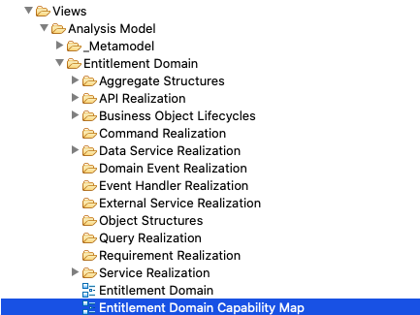

Business Capabilities Map uses “**resources**” and “**capabilities**” objects type in Archimate. **Domains** and **Sub-domains** are modelled as Resources and **Business Capabilities** as Capabilities. All the elements are placed under the respective folders

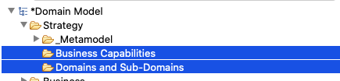

The following picture is the template for Capability Maps:



## API Layer

API layer is described with API, API responses and API resources.



The API layer never implement business logic, but uses Commands, Queries and Services to access the data and business logic implemented in the Domain.

Commands, Queries and Services are components from the Core Domain and are further described in the corresponding section

### API Inventory

API are created in Archimate template under the Business/API Folder

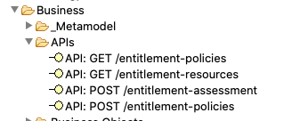

Use the Property Tab to provide the name and description:

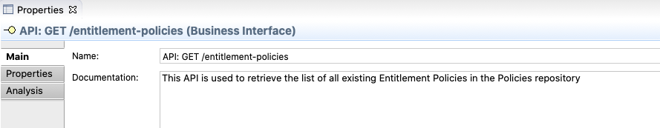

Set the “Type” in the Property Field to “API¨:

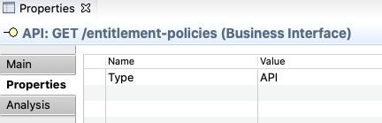

### API Specification

We use API realization diagram describes the implementation of the API including the commands and services used to provide the business logic and data required the API. The API realization diagrams are in the folder as shown below:

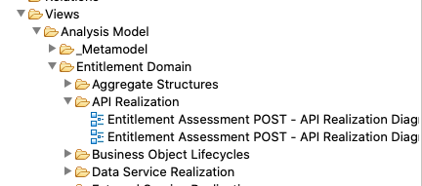

Model of Diagram:

#### Requests

Requests resources are modeled with API Resources (Entity objects in Archimate)

API resources are placed in the API Resource Folder

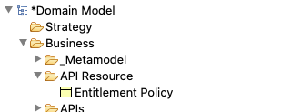

Use the Property Tab to enter name and description, and classify the element as “API Resource” or copy/paste one from the metamodel folder

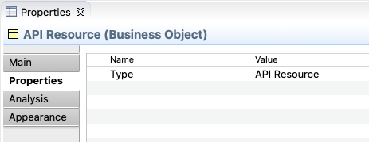

#### Responses

Responses are modeled with Response objects (Representation objects type in Archimate) Each Response has associated an Entity, which models the resource (the data) provided in the response.

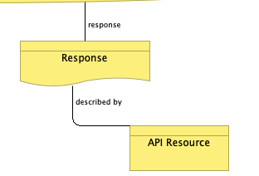 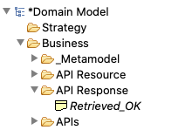

Responses are placed in the API Response folder

Use Properties to set name and description. Do not reuse. Each Response may have a different output resource associated for each different API

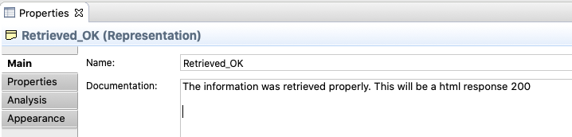

Create a property Type with “API Response”

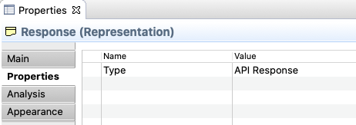

The valid responses types can be found in the API responses folder and the “Metamodel: API Response” View

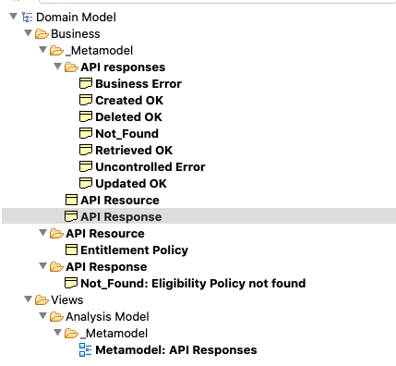

Valid Responses are shown below. Copy and Paste one of them to create a response for your APIs



#### API Realization

The Diagram describes the Services, Commands or Queries in the Core Domain that the API uses to provide the responses.

We use the Logic Descriptor to write down the logic to be implemented in the API, such as data mappings, validations, etc.



The API receives or send a payload described by Entities, as described above, and the commands, services or query will have their own interface. The data in the API must be mapped to the interfaces. When API payloads and Services, Command or Queries interfaces are not clearly similar, mapping instructions should be provided. To do so, a “logic descriptor” element is used

We´ll use simple text to describe how mapping is to be done. The analyst is welcome to use tables such as the one below. This cannot be achieved in Archimate and should be a necessary manual step when creating the deliverable in MS Word.

| **Target Field** | **Source Field** | **Comments** |
| --- | --- | --- |
|  |  |  |
|  |  |  |

### API Resources Specifications

API resources are modeled as Business Objects, following the same approach. Please see the “Objects” sections of this guide

## Core Domain

The Core Domain implement the business logic and will manage the data of the domain. It uses the integration layer to access external services and data. It is used by the API layer to expose the services provided by the domain.



The Core Domain is described by:

* **Aggregates**, data structures used to organize the information used and managed in the domain. **Entities** and **Value** **Objects** are used to structure the aggregates
* **Commands**. Components to create and manipulate the data in the domain
* **Queries**. Similar to commands, but with the purpose of retrieving data, while commands responsibility is to create or alter the data.
* **Service**. Encapsulation of business logic for reusability or whether it is complex, and we don´t want to place complex logic in the commands.
* **Domain Event** are used to publish information on changes in the states of the domain aggregates

### Aggregates

Aggregates are the elements used to model the information managed or use within the domain and provides the ubiquitous language of the Domain

Aggregates are described using “Aggregate Structure Views”. These views are under the “Aggregate Structure” folder in the template

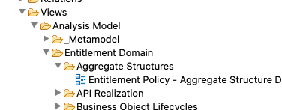

The following is the template for an aggregate structure.



An aggregate is made or a root-entity and includes entities. Both root-entities and entities are modeled as Objects. See 7.9 for instructions on Object Modelling.

Aggregates are created as Root-Entity objects and placed in the Business Object folder of the templated

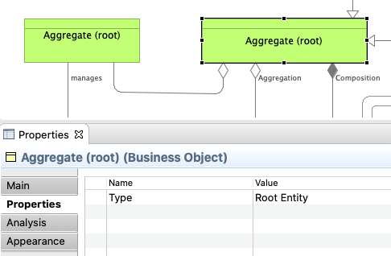 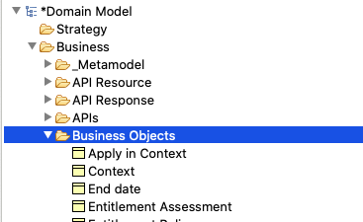

Entities are defined as Type: Object and placed in the same folder.

### Aggregate and Entity Lifecycle Diagrams

These diagrams describe the states of the lifecycle of aggregates and entities, the allowed transitions between states and the pre-conditions (constrains) for such transitions

These diagrams are placed under the **business object lifecycle** folder in the template:

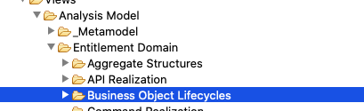

Next picture describes the Template for this type of diagram. It includes the states, the entities and aggregate of the states, the valid flows between states and the commands that will cause the state transition.



### Commands Specification

Commands are the components in charge of creating or modifying the data in the aggregates. They are called whenever new data has to be persisted in the domain

Commands are modeled using Business Services elements in Archi within the folder “Commands”. Commands are described in Command Realization Diagram. Diagrams are placed under Command realization folder

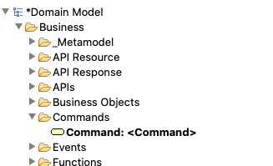 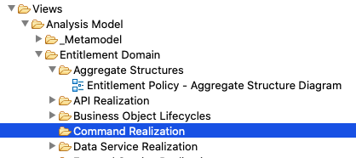

The commands (such as the queries and the services) implement the business logic in the domain. Logic is described in Logic Descriptor elements as simple text in the Documentation space of the Properties of the element. We also create flows using Task elements to provide clarification. We use specifically Tasks to detail the mapping instructions to the interfaces of the services called. Logic Descriptors and Task are created using the Business Function object in Archimate and classifying them with a Type Attribute:

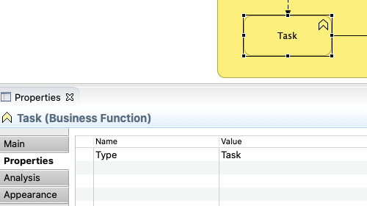 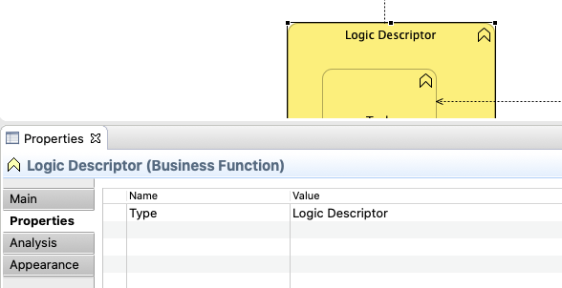

Next picture shows the template for the Command Realization. It the picture we can see:

* **Interfaces** of the Command (input / outputs) are described using entities;
* The first Task describes a step when we are retrieving data from an **aggregate** or an **entity**. The task description should provide the necessary instructions to explain the designer how the access is done (i.e retrieve a “Policy Criteria” using the Criteria ID…);
* The second Task describes a step when we are calling an **External Service**. The task description should provide the necessary instructions to explain to the designer how to call the service (how to populate the input interface of the called services) will be done;
* The third Task describes a step when we are calling a **Domain Service**. The task description should provide the necessary instructions to explain to the designer how to call the service (how to populate the input interface of the called services) should be done;
* The fourth Task describes a step when we persist data into the domain. The task description should provide the necessary instructions to explain to the designer what entity is created, updated or deleted;
* The last Task generates a **Domain** **Event**. The task description should provide the necessary instructions on how to populate the information required to create the event.



### Service Specifications

Services are the components where we encapsulate business logic to be reused or when it´s very complicated and we don´t want to add complexity to the Commands.

Services are modeled using Business Services elements in Archi within the folder “Services”. Services are described in Service Realization Diagram. Diagrams are placed under “Service Realization” folder

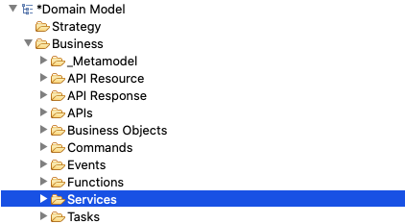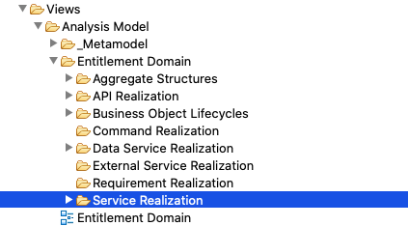

The services implement the business logic in the domain. Services are modelled like the commands. Please refer to the previous section for details on Command modeling. The only difference is that Services cannot persist data. This is exclusive of Commands. Services uses commands to alter the aggregates in the Domain.

The next picture provides a template for Services:



### Query Specifications

Services are the components we use to retrieve data based on different criteria. We only need to define a query component when we face non-standard access requirements (different of GetByID or GetAll). For example, to retrieve customers which belong to a specific group.

Queries are modeled using Business Services elements in Archi within the folder “Queries”. Queries are described in Query Realization Diagram. Diagrams are placed under “Query Realization” folder

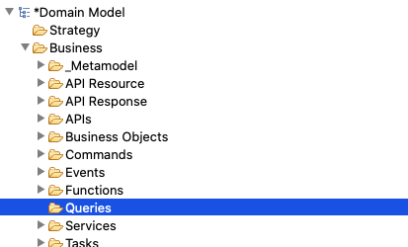 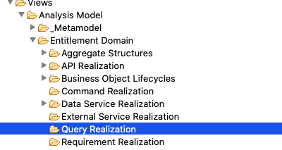

Queries are modelled like the Services. Please refer to the previous section in the document for details. The next picture provides a template for Queries realization diagrams:

### Domain Events

Domain Events are the business events emitted by the Domain for other domains to subscribe to changes in the resources of the Domain.

They are created under the “Domain Folder” and described in Domain Event Realization Diagrams.

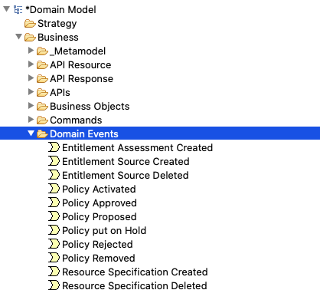 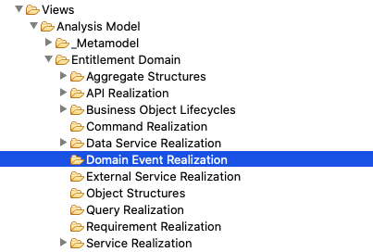

**Domain Event Realization** diagrams are simple diagram that specifies the structure of the **Events** using **Objects**



Use the property tab to provide name and description of the Domain Event:

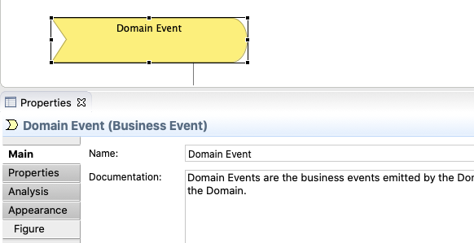

### Objects

Objects are described as “Business Entities” Archimate objects.

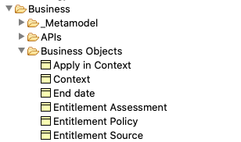

“Object Structure Views” are used to describe the Object Structures. They are placed in the Object Structure folder:

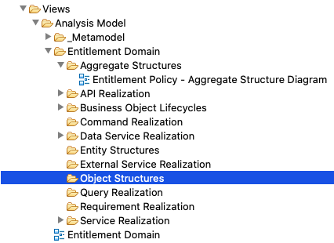

Next picture is the sample template for Object Structure View:



.

Objects contains attributes. Attributes can be primitives’ types or other objects.

To define the structure, we use aggregation and composition relationships as can be seen in the picture. We use composition for single objects and aggregation for collection of objects, when an object contains not a single, but a collection of objects in one of the attributes

Non-object attributes must be subtype with a primitive, for example the Start Data with a Data Primitive in the following figure with a sample. A not-subtyped is understood to be a complex object.

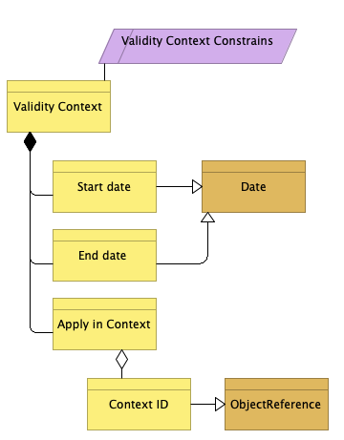

Mandatory fields and other constrains can be specified with a constrains object as in the figure. For example:

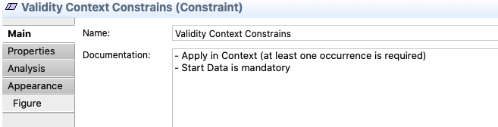

Valid Primitives can be found in the Metamodel folders:

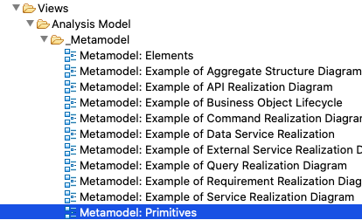 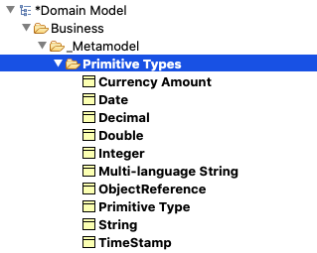

The current primitives can be see found below. New ones will be added to the template as needed:



## Integration Layer

The integration layer implements the access mechanism to data and services in other domains. Its main purpose is to transform the data received from other domain via APIs or Event to the domain language, this means to the data structures of the domain. The business logic is built exclusively using the domain data models and never data-models of other domains (i.e the payload structures of the consumed APIs)



Components in the Core Domain uses external services to access data or services in other domains, as was described in the Core Domain section of the document

Event Handlers use Commands and Services in the Core Domain to alter the domain aggregates as a result of an External Event. For example, an event informing in the change of the status of a credit offer may trigger actions in the Customer Request domain, for the customer requests related to such credit offer

### External Events

External Events are business events published by other domains that trigger any kind of response in our Domain.

For example, an event informing in the change of the status of a credit offer may trigger actions in the Customer Request domain, for the customer requests related to such credit offer

External Events are created in the **External Event** folder in the template

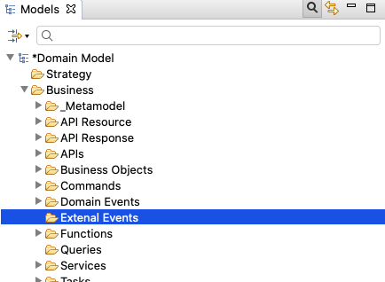

External Events are described in the Event Handler Realization Diagrams (where we specify the object used to describe the structure of the Event), and in the External Event Property Tab.

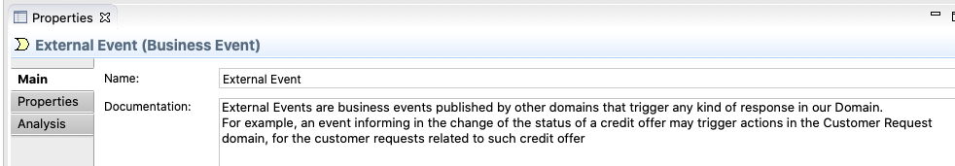

Event Handler Realization Diagrams are described in the next section of the document.

### Events Handlers

Event Handlers are components of the domains responsible to receive the event and use the information contained in the Event to trigger actions in the core domain, for example, to update information in one of the aggregates.

Event Handlers are modeled using Event Handlers elements in Archi within the folder “Event Handlers”. Services are described in Event Handlers Realization Diagram. Diagrams are placed under “Event Handler Realization” folder

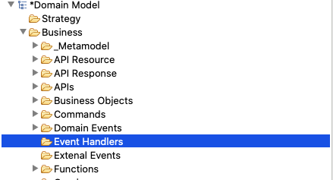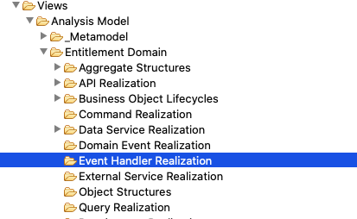

Event Handlers are modelled like the Services. Please refer to the 7.6 section for details on Service modeling. The main difference with services is that even handlers do not emit Domain Events.

The next picture provides a template for Event Handlers:



### External API and External Domains

External APIs are services provided by other domains that are used by our domain to obtain data or request a service

External APIs are created in the **External APIs** folder in the template

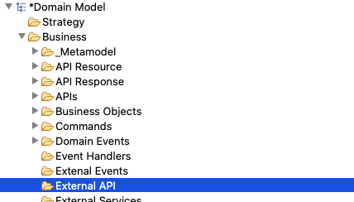

External APIs are described in the **External Service Realization** Diagrams, and in the External API Property Tab.

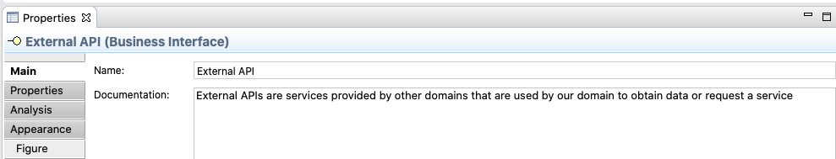

External Service Realization Diagrams are described in the next section of the document.

External Domains model the systems owners of the External APIs

External Domains are created in the **External Domains** folder in the template

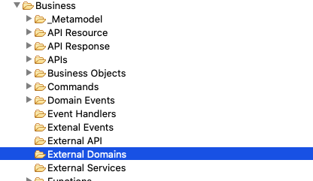

External Domains are described in the **External Service Realization** Diagrams, and in the External Domains Property Tab.

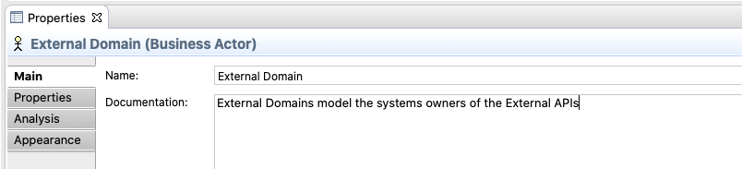

External Service Realization Diagrams are described in the next section of the document.

### External Services

External Services are the components of the domains responsible to access information of Services in other domain, by calling the APIs of those domains.

The External Services´ main responsibility is to transform the data received to the “ubiquitous language” of the domain, which means to provide the information in the structure defined by the aggregates of the Domain. This is done to avoid the business logic to rely in data elements proprietary of other domains, which would mean a strong coupling element.

External Services are modeled using Event Service elements in Archi within the folder “External Services”. External Services are described in External Services Realization” Diagrams. Diagrams are placed under “External Services Realization” folder

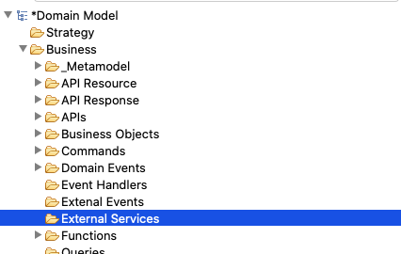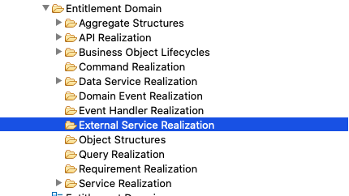

The next picture provides a template for External Services:



Next picture shows the template for the External Service Realization. It the picture we can see:

* **Interfaces** of the service (input / outputs) are described using objects;
* Tasks describing the calls **External API**. The task description should provide the necessary instructions to explain to the designer how to call the external API (how to populate the input interface of the called API) will be done;
* The **External Domain** that owns the External API
* The requirement created in JIRA for the other domain team to provide the needed API